Interview Questions

Section 1: Open-Ended Questions

Q1. How do you currently manage property listings and customer inquiries?
We keep property details in paper files and Excel sheets. Customers call or send WhatsApp messages, the agent writes the inquiry in a notebook, and then follows up by phone.

Q2. What are the biggest difficulties you face in your daily work?
Searching takes a long time, information is in different places, and we sometimes forget to update whether a property is sold or rented. Some inquiries get lost.

Q3. How do you find a suitable property when a customer asks for one?
The agent tries to remember suitable properties, then checks the paper files and Excel sheets one by one and calls the owners to confirm.

Q4. What features would you like the new system to have?
Search by location, price and property type; a page for each property with photos and details; an inquiry form for customers; and an easy way to change the status of a property.

Q5. How do you imagine the new system would improve your work?
We would save time, find properties in minutes, answer customers faster and have less paperwork.

Section 2: Closed Questions

Q6. How are property details stored now?
☒ Paper files ☒ Excel sheets ☐ Software system ☐ Other

Q7. How many customer inquiries do you receive per day?
☐ Fewer than 5 ☐ 5 to 10 ☒ 11 to 20 ☐ More than 20

Q8. How often is the availability of properties (available / sold / rented) updated?
☐ Daily ☒ Weekly ☐ Monthly ☐ Only when asked

Q9. Which device would agents use most to access the new system?
☐ Desktop ☐ Laptop ☒ Mobile ☐ Tablet

Q10. Would you prefer a web-based system that can be accessed from any device?
☒ Yes ☐ No

Real Estate Form

URL of the form:
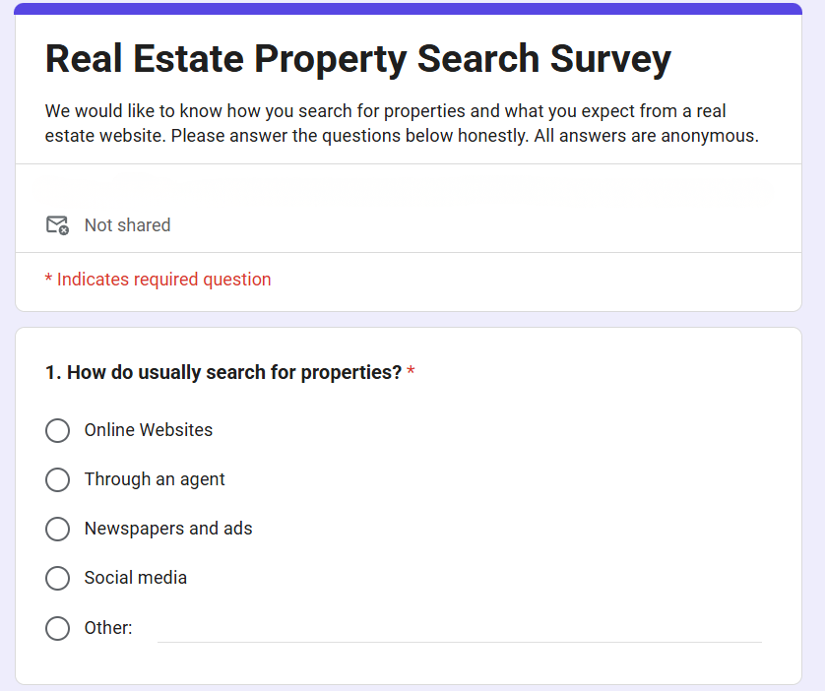
https://docs.google.com/forms/d/e/1FAIpQLSd743vvwZPjCMkyAVR_ut7enhOBsViJi940xrRW8ARQXoDY0Q/viewform?usp=header\
